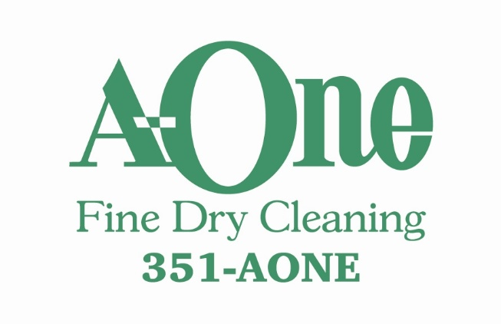
NOVEMBER SPECIAL
All Tablecloths
$15.00
www.a-onecleaners.com

