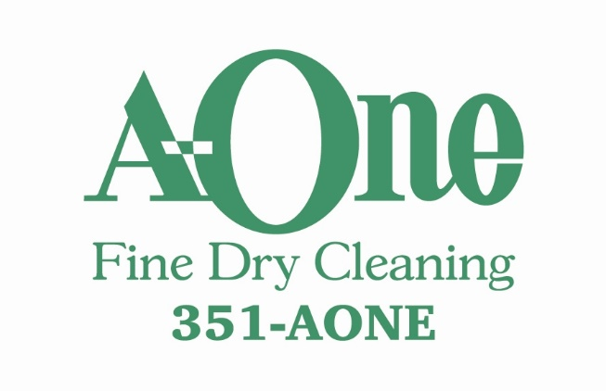
JANUARY SPECIAL
$2.00 OFF
All Sweaters
www.a-onecleaners.com

