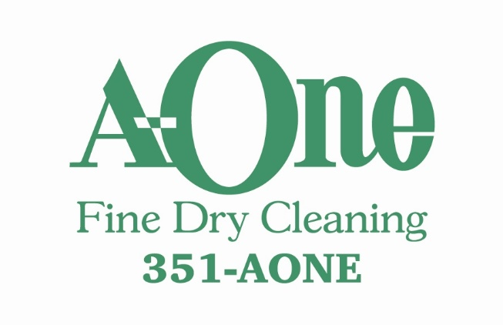
SEPTEMBER SPECIAL
$5.00 OFF
All Comforters, Bedspreads and Down Pillows
www.a-onecleaners.com

